Goring Heath and Whitchurch
Spring Show

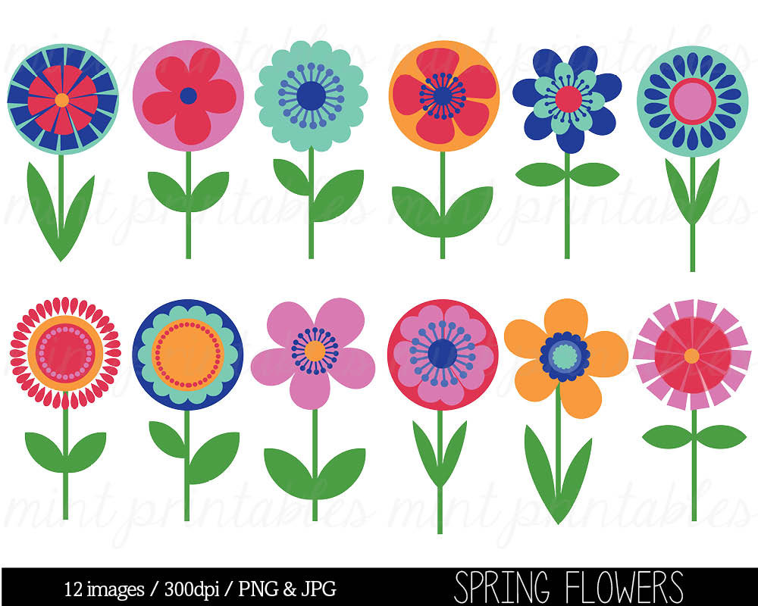
Saturday 13 April 2019
2.30 pm to 4.00 pm
Goring Heath Parish Hall

OPEN TO ALL RESIDENTS OF GORING HEATH AND WHITCHURCH
Entry Forms should be given to a Committee member from Wednesday 10 April and no later than 4.30pm on Friday 12 April 2019.

PROGRAMME
Exhibitors’ staging | 9.00 am – 10.15 am
Judging | 10.30 am - 12.30 pm
Open for public viewing | from 2.30 pm
Presentation of Trophies | 3.30 pm
Raffle | 3.45 pm approx

* Refreshments available all afternoon *
Entry forms and schedules can be downloaded from
www.whitchurchonthames.com/diary.php
and
www.goringheath.com
Trophies and Prizes
- The Betty Hayter Memorial Cup will be awarded to the Competitor with the most points in Section A (Flowers).
- A Floral Arrangement Trophy will be awarded to the Competitor with the most points in Section C (Flower Arranging).
- A Handicraft Trophy will be awarded to the Competitor with the most points in the Handicraft Classes.
- An Art Trophy will be awarded to the Competitor with the most points in the Art Classes
- An Arts and Crafts Trophy will be awarded to the Competitor with the most points in Section D for Art and Handicraft.
- An Egg Cup will be awarded to the competitor with the most points gained in Section F.
- Baking and Preserves Cup will be awarded to the Competitor with the most points in Section G.
- The Photography Cup will be awarded to the Competitor with the most points in Section H.
- The Douglas Allardyce Memorial Rose Bowl will be awarded to the most outstanding exhibit in the Vegetable, Fruit and Flower Sections A and B.
- A Cup and rosettes will be awarded to the winner/s of Section E (Children up to 12 years of age).
- The Whitchurch Hill Trophy will be awarded to the Competitor with the most points overall.
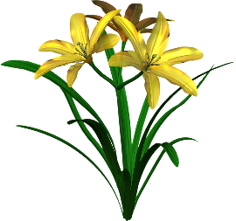
SECTION A
FLOWERS
Judge – Rodney Davies
NOTE: The distinguishing characteristic of a trumpet daffodil is one flower on a stem; its trumpet or corona is as long or longer than the perianth segments (outer petals). Blooms with shorter trumpets should be exhibited in the narcissus classes. ‘Mixed’ means more than one variety.
- Specimen bloom of trumpet daffodil, any colour
- Specimen bloom or stem of narcissus, any colour
- Vase of trumpet daffodils, three varieties, one bloom of each
- Vase of narcissi, three varieties, one bloom of each
- Vase of narcissi, three stems, with more than one bloom of each
- Vase of miniature daffodils or narcissi, three stems of one variety
- One specimen bloom of tulip
- Vase of tulips, three blooms, mixed or single variety
- Vase of muscari (grape hyacinth), six stems
- Vase of polyanthus, five stems
- Vase of primroses, five stems
- Vase of hellebores, colour variation allowed, five stems
- Vase of spring flowers, outdoor grown, one kind, colour variation allowed, five stems
- Vase of mixed spring flowers, with own foliage, excluding shrubs, five stems
- Vase of flowers from trees or shrubs, mixed, five stems
- An alpine plant, in the exhibitor’s possession for at least six months, maximum pot size 7ins/18cms
- Pot or bowl of any flowering plant(s), including bulbs, corms or tubers, maximum pot size 10ins/24cms
- Pot or bowl of succulent or succulents, maximum pot size 7ins/18cms
- Pot or bowl of a cactus or cacti, maximum pot size 7ins/18cms

SECTION B
FRUIT AND VEGETABLES
Judge – Rodney Davies
- Four sticks of rhubarb to be shown with leaves trimmed to 3ins/7.5cms and the bottom white heel left on
- Any variety of vegetable, other than rhubarb, number optional

SECTION C
FLOWER ARRANGING
Judges – Sally and Lorna Woolhouse
To be viewed from the front, dimensions not to exceed 16ins/40cms.
- A candle decorated with fresh flowers (candle not to exceed 12”, 30cm)
- A hand tied posy
- An arrangement in an egg cup
SECTION D
ARTS AND CRAFTS
Judges – Sally and Lorna Woolhouse
HANDICRAFT
- An item for a pram (sewn, knitted or crocheted)
- An Easter card
- A cushion cover
ART
No item larger than A3
- Spring Flowers
- My Favourite Pet
- A shady glade
Competitors are responsible for supplying their own equipment to display their entries, unless otherwise stated

SECTION E
CHILDREN (UP TO 12 YEARS)
Judges – Sally and Lorna Woolhouse
Children’s ages must be written on exhibitors’ cards
- A painted egg in an egg cup
- A decorated biscuit (to be judged on the decoration)

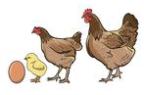
SECTION F
EGGS
Judge – Caroline Hadley
- Three identical hens’ eggs
- Three bantam eggs, same colour
- Three waterfowl eggs
- Six eggs, attractively displayed
SECTION G
BAKING AND PRESERVES
Judge – Regula Adams
Jars must be plain and have fresh labels as required. The preserves must be covered with a wax circle and a cellophane top. Jars to be filled within 6mm of the top.
- A jar of lemon curd
- A jar of three fruit marmalade
- Fruit cake (recipe supplied}
- Four Viennese fingers (recipe supplied)
Fruit Cake
Ingredients
100g (4oz) Caster Sugar
100g (4oz) Margarine
125 ml Milk (less two tablespoons)
2 Eggs
300g (10oz) Mixed Dried Fruit
200g (7oz) SR Flour
1 level tsp Mixed Spice

Method
Place all ingredients in mixing bowl. Beat with wooden spoon until well mixed (2-3 minutes). Place in a greased and lined 2lb (1 Kg) loaf tin and smooth top. Bake at 325f/160c/140fan or Gas Mark 3 for one hour.
Viennese Fingers (makes 12)
Ingredients
175g/6oz butter or marg.
50g/2oz icing sugar
Grated rind of 1 orange
125g/4oz plain flour
50g/2oz cornflour
2 tablespoons apricot jam
75g/3oz plain chocolate
1 drop vanilla essence

Method
Pre heat oven to 180c/350f/160fan or gas mark 4. Cream the butter or marg together with the orange rind until light and fluffy. Sift in the flour and cornflour and beat well. Place in a piping bag fitted with a 2.5cm/1 inch fluted nozzle and pipe 7.5m/3” fingers well apart on a baking sheet lined with non-stick paper.
Bake in preheated oven for 15 minutes. Transfer to a wire rack to cool.
Sandwich the fingers together in pairs with a little jam. Melt the chocolate in a small bowl over a pan of hot water. Dip both ends of the fingers in the chocolate and place on a piece of greaseproof paper.
Leave until set.
SECTION H
PHOTOGRAPHY
Judge – Jim Donahue
Entries may be in black & white or
colour. Maximum size A4 (29.7cm x
21cm / 11.7” x 8.3” including mount. You may only enter one photograph per class.
- A Christmas scene
- A Country Road
- A Garden in Winter
SUMMER SHOW
Saturday 7 September 2019
Photography Section Classes
Over the Hill
Cheers
Chimneys

Judith Johns  Crayside, Whitchurch Road  Crays Pond  0118 9842816 | Liz Gibson  Nurses Cottage, Bridle Road  Whitchurch Hill, 0118 984 2012  liznursescott@talktalk.net
Sue Sexon  3 Rivacres  Whitchurch Hill  0118 984 4236  suesexon@yahoo.co.uk | Sally Trinder  The Gables, Eastfield Lane  Whitchurch-on-Thames  0118 984 2610  sallytrinder@talktalk.net
Rules of Entry
1. Entry Forms 30p per entry must reach the organisers, as detailed in this schedule. Late entries (50p) are at the discretion of the Committee.
2. Entry is open to residents of Whitchurch and Goring Heath, plus children attending schools and allotment holders within the two Parishes.
3. An individual may only make one entry per class.
4. Two or more persons may not exhibit separately in the same class in the Flower and Fruit and Vegetable Sections from the same garden or allotment.
5. Exhibitors in all Sections are expected to be local amateurs.
6. Exhibits in the Flower and Fruit and Vegetable Sections must have been grown by the exhibitor in his/her own garden or allotment.
7. Exhibits must be staged on the day of the Show between the times stated in this schedule. No exhibit may be removed before the end of the Show.
8. The Committee will not be held responsible for any loss or damage, although every care will be taken to avoid it.
9. Accessories in the Flower Arranging Class must not predominate over plant material.
10. Exhibits in the Baking and Preserves Section must be homemade.
11. The decisions of the judges are final. If there are three or fewer entries in one class, prizes may be awarded or not, at the discretion of the judges.
12. All items should be exactly as described in the schedule or they may be disqualified.
13. Trophies may be held until the following Show. Winners are asked to return them to the organiser one month before the following show.
14. Children’s ages must be included on the entry form.

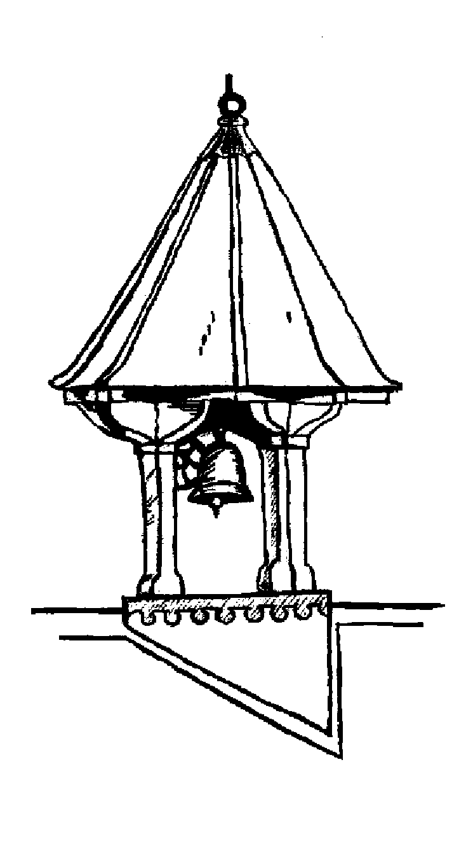
Goring Heath Parish Charity
SPRING 2019 SHOW
ENTRY FORM
Please use the form below for your entries.
Number of entries: ___ I enclose fees (30p per entry): ___
Name : _________________ Tel No : ________________
Address : ______________________________________
___________________________ Age of child : ________
All entry forms should be given to a member of the committee from Wednesday 10 April and no later than 4.30pm on Friday 12 April 2019. Late entries only at the discretion of the committee. See overleaf for contact details.
Please circle below the number of each class you are entering.

Section | Class
A | 1 | 2 | 3 | 4 | 5 | 6 | 7 | 8 | 9 | 10 | 11 | 12 | 13 | 14 | 15 | 16
A | 17 | 18 | 19
B | 20 | 21
C | 22 | 23 | 24
D | 25 | 26 | 27 | 28 | 29 | 30
E | 31 | 32
F | 33 | 34 | 35 | 36
G | 37 | 38 | 39 | 40
H | 41 | 42 | 43 | 44

Please make sure that you read the schedule carefully. For copies of schedule or entry form please go to http://www.whitchurchonthames.com/diary.php or www.goringheath.com

